1. Create a Spring Web Project using Maven
Answer:
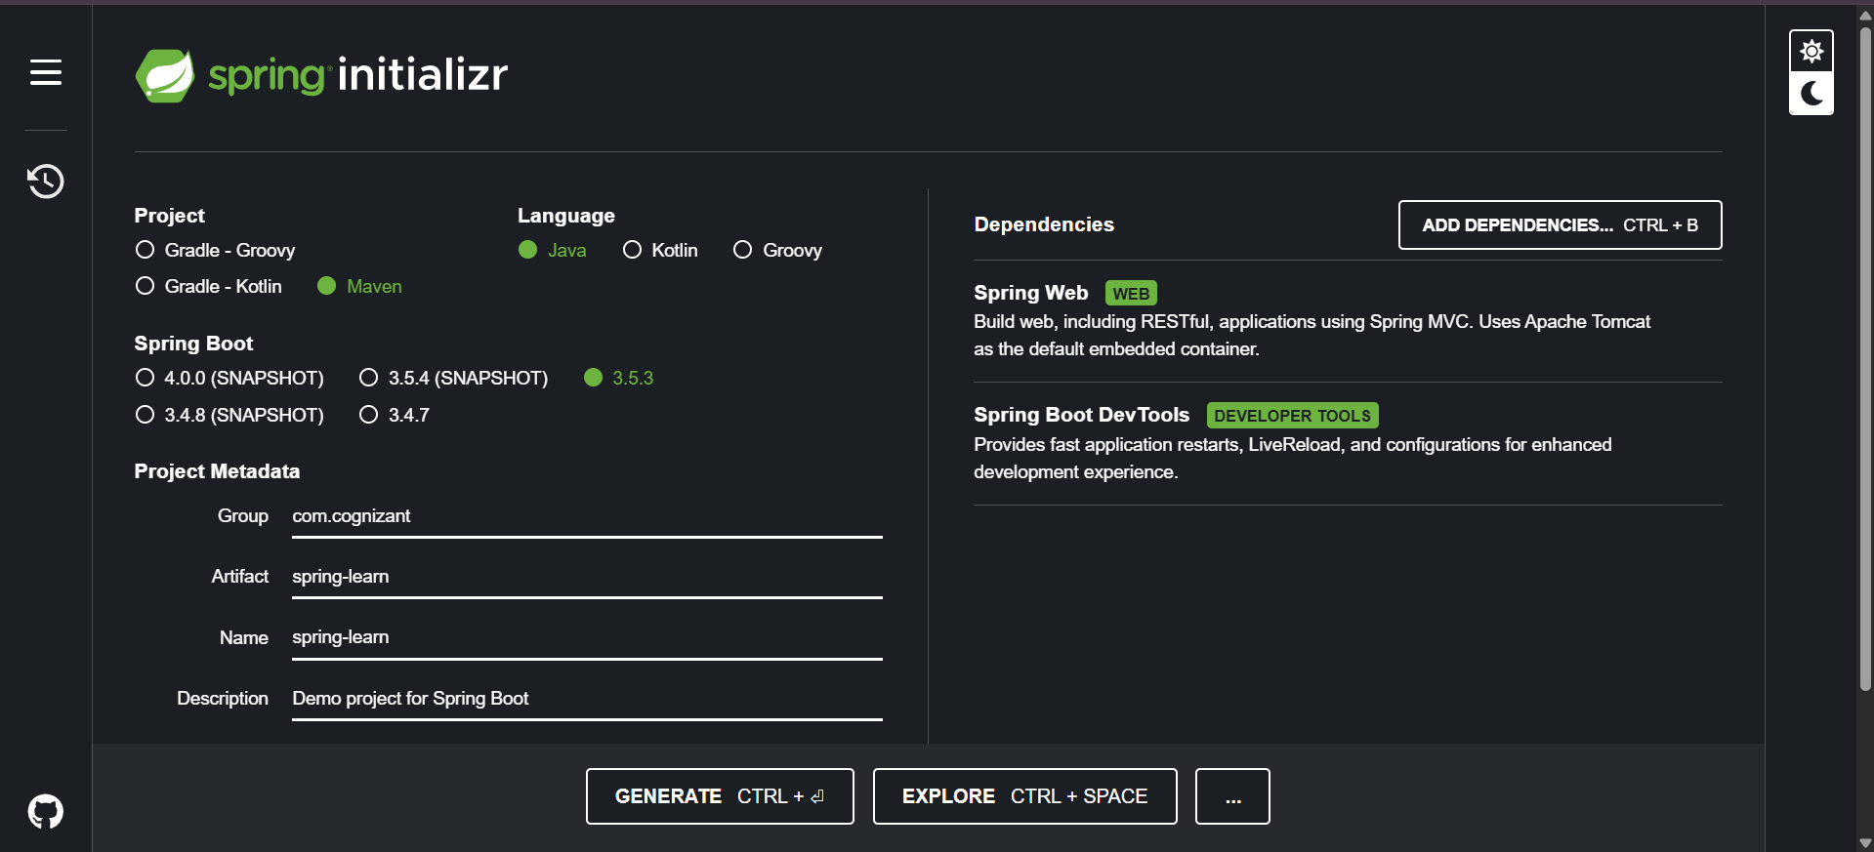
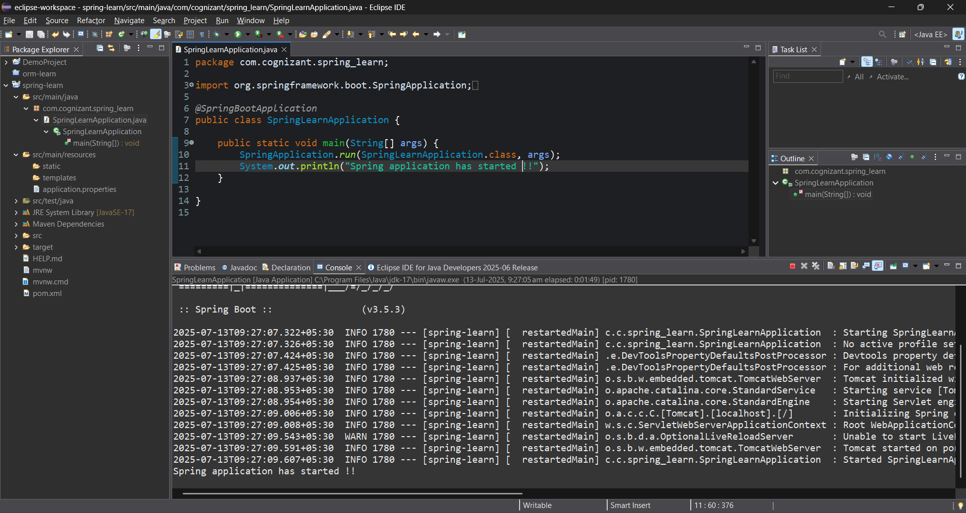
2. Spring Core – Load Country from Spring Configuration XML
Answer :
PROGRAM :
//Country.java
package com.cognizant.spring_learn;

import org.slf4j.Logger;
import org.slf4j.LoggerFactory;

public class Country {
private static final Logger LOGGER = LoggerFactory.getLogger(Country.class);

private String code;
private String name;

public Country() {
LOGGER.debug("Inside Country Constructor.");
}

public String getCode() {
LOGGER.debug("Inside getCode()");
return code;
}

public void setCode(String code) {
LOGGER.debug("Inside setCode()");
this.code = code;
}

public String getName() {
LOGGER.debug("Inside getName()");
return name;
}

public void setName(String name) {
LOGGER.debug("Inside setName()");
this.name = name;
}

@Override
public String toString() {
return "Country [code=" + code + ", name=" + name + "]";
}
}
//country.xml
<?xml version="1.0" encoding="UTF-8"?>
<beans xmlns="http://www.springframework.org/schema/beans"
xmlns:xsi="http://www.w3.org/2001/XMLSchema-instance"
xsi:schemaLocation="
http://www.springframework.org/schema/beans
https://www.springframework.org/schema/beans/spring-beans.xsd">

<bean id="country" class="com.cognizant.spring_learn.Country">
<property name="code" value="IN" />
<property name="name" value="India" />
</bean>

</beans>
//SpringLearnApplication.java
package com.cognizant.spring_learn;

import org.slf4j.Logger;
import org.slf4j.LoggerFactory;
import org.springframework.context.ApplicationContext;
import org.springframework.context.support.ClassPathXmlApplicationContext;
import org.springframework.boot.SpringApplication;
import org.springframework.boot.autoconfigure.SpringBootApplication;

@SpringBootApplication
public class SpringLearnApplication {

private static final Logger LOGGER = LoggerFactory.getLogger(SpringLearnApplication.class);
public static void main(String[] args) {

SpringApplication.run(SpringLearnApplication.class, args);
displayCountry();
}

public static void displayCountry() {
ApplicationContext context = new ClassPathXmlApplicationContext("country.xml");
Country country = context.getBean("country", Country.class);
LOGGER.debug("Country : {}", country.toString());
}

}

OUTPUT:
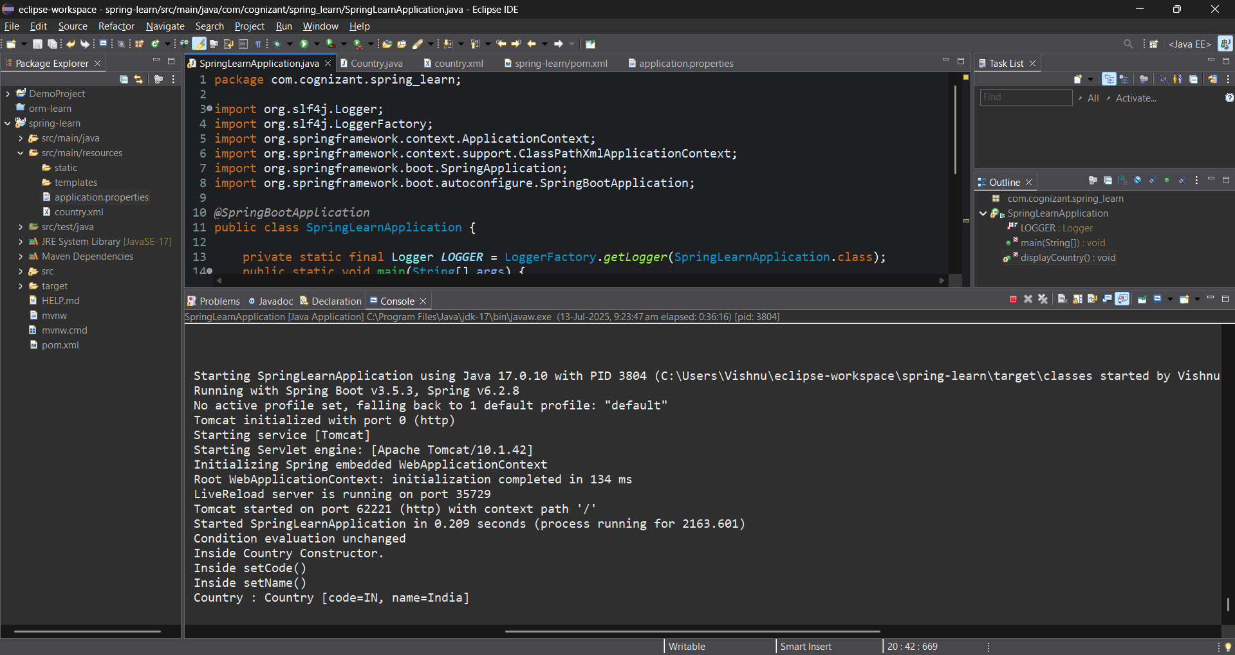
3. Hello World RESTful Web Service
ANSWER:
PROGRAM:
//HelloController.java
package com.cognizant.spring_learn.controller;

import org.slf4j.Logger;
import org.slf4j.LoggerFactory;
import org.springframework.web.bind.annotation.GetMapping;
import org.springframework.web.bind.annotation.RestController;

@RestController
public class HelloController {

private static final Logger LOGGER = LoggerFactory.getLogger(HelloController.class);

@GetMapping("/hello")
public String sayHello() {
LOGGER.debug("Start: sayHello()");
String response = "Hello World!!";
LOGGER.debug("End: sayHello()");
return response;
}
}
OUTPUT:
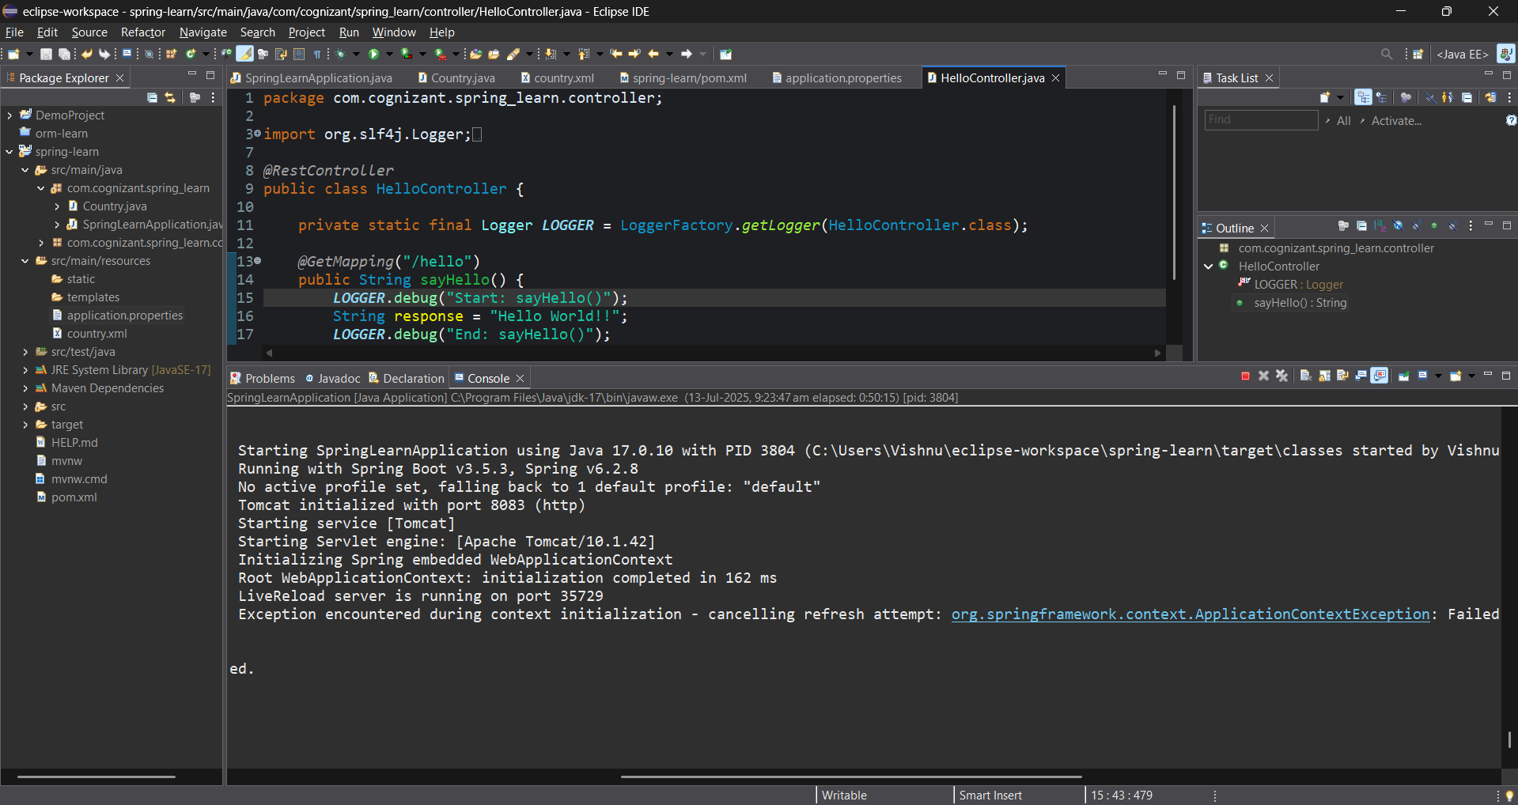
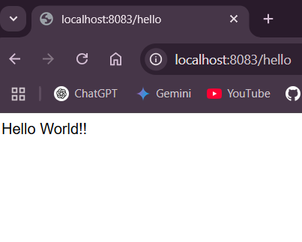
4. REST - Country Web Service
ANSWER:
PROGRAM:
//CountryController.java
package com.cognizant.spring_learn.controller;

import com.cognizant.spring_learn.Country;
import org.slf4j.Logger;
import org.slf4j.LoggerFactory;
import org.springframework.context.ApplicationContext;
import org.springframework.context.support.ClassPathXmlApplicationContext;
import org.springframework.web.bind.annotation.RequestMapping;
import org.springframework.web.bind.annotation.RestController;

@RestController
public class CountryController {

private static final Logger LOGGER = LoggerFactory.getLogger(CountryController.class);

@RequestMapping("/country")
public Country getCountryIndia() {
LOGGER.debug("Start: getCountryIndia()");
ApplicationContext context = new ClassPathXmlApplicationContext("country.xml");
Country country = context.getBean("country", Country.class);
LOGGER.debug("End: getCountryIndia()");
return country;
}
}
//country.xml
<?xml version="1.0" encoding="UTF-8"?>
<beans xmlns="http://www.springframework.org/schema/beans"
xmlns:xsi="http://www.w3.org/2001/XMLSchema-instance"
xsi:schemaLocation="
http://www.springframework.org/schema/beans
https://www.springframework.org/schema/beans/spring-beans.xsd">

<bean id="country" class="com.cognizant.spring_learn.Country">
<property name="code" value="IN" />
<property name="name" value="India" />
</bean>

</beans>
OUTPUT:
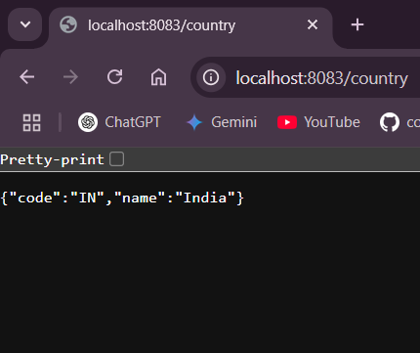
5. REST - Get country based on country code
ANSWER:
PROGRAM:
//CountryController.java
package com.cognizant.spring_learn.controller;

import com.cognizant.spring_learn.Country;
import com.cognizant.spring_learn.service.CountryService;
import org.slf4j.Logger;
import org.slf4j.LoggerFactory;
import org.springframework.beans.factory.annotation.Autowired;
import org.springframework.web.bind.annotation.*;

@RestController
public class CountryController {

private static final Logger LOGGER = LoggerFactory.getLogger(CountryController.class);

@Autowired
private CountryService countryService;

@GetMapping("/countries/{code}")
public Country getCountry(@PathVariable String code) {
LOGGER.debug("Start: getCountry() with code {}", code);
Country country = countryService.getCountry(code);
LOGGER.debug("End: getCountry()");
return country;
}
}
//country.xml
<?xml version="1.0" encoding="UTF-8"?>
<beans xmlns="http://www.springframework.org/schema/beans"
xmlns:xsi="http://www.w3.org/2001/XMLSchema-instance"
xsi:schemaLocation="
http://www.springframework.org/schema/beans
https://www.springframework.org/schema/beans/spring-beans.xsd">

<bean id="countryList" class="java.util.ArrayList">
<constructor-arg>
<list>
<bean class="com.cognizant.spring_learn.Country">
<property name="code" value="IN"/>
<property name="name" value="India"/>
</bean>
<bean class="com.cognizant.spring_learn.Country">
<property name="code" value="US"/>
<property name="name" value="United States"/>
</bean>
<bean class="com.cognizant.spring_learn.Country">
<property name="code" value="JP"/>
<property name="name" value="Japan"/>
</bean>
<bean class="com.cognizant.spring_learn.Country">
<property name="code" value="DE"/>
<property name="name" value="Germany"/>
</bean>
</list>
</constructor-arg>
</bean>
<bean id="country" class="com.cognizant.spring_learn.Country">
<property name="code" value="IN"/>
<property name="name" value="India"/>
</bean>
</beans>

//SpringLearnApplication.java
package com.cognizant.spring_learn;

import org.slf4j.Logger;
import org.slf4j.LoggerFactory;
import org.springframework.context.ApplicationContext;
import org.springframework.context.support.ClassPathXmlApplicationContext;
import org.springframework.boot.SpringApplication;
import org.springframework.boot.autoconfigure.SpringBootApplication;

@SpringBootApplication
public class SpringLearnApplication {

private static final Logger LOGGER = LoggerFactory.getLogger(SpringLearnApplication.class);
public static void main(String[] args) {

SpringApplication.run(SpringLearnApplication.class, args);
displayCountry();
}

public static void displayCountry() {
ApplicationContext context = new ClassPathXmlApplicationContext("country.xml");
Country country = context.getBean("country", Country.class);
LOGGER.debug("Country : {}", country.toString());
}

}
OUTPUT:
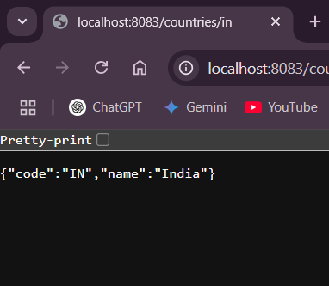
6. Create authentication service that returns JWT
ANSWER:
PROGRAM:
//AuthenticationController.java
package com.cognizant.spring_learn.controller;

import jakarta.servlet.http.HttpServletRequest;
import org.springframework.web.bind.annotation.*;
import org.springframework.http.ResponseEntity;
import org.springframework.beans.factory.annotation.Autowired;
import com.cognizant.spring_learn.security.JwtUtil;

import java.util.Base64;

@RestController
public class AuthenticationController {

@Autowired
private JwtUtil jwtUtil;

@RequestMapping("/authenticate")
public ResponseEntity<?> authenticate(HttpServletRequest request) {
System.out.println(">> Inside /authenticate"); // DEBUG LOG

String authHeader = request.getHeader("Authorization");

if (authHeader == null || !authHeader.startsWith("Basic ")) {
return ResponseEntity.status(401).body("Missing or invalid Authorization header.");
}

String base64Credentials = authHeader.substring("Basic ".length());
String credentials = new String(Base64.getDecoder().decode(base64Credentials));

String[] values = credentials.split(":", 2);
String username = values[0];
String password = values[1];

if ("user".equals(username) && "pwd".equals(password)) {
String token = jwtUtil.generateToken(username);
return ResponseEntity.ok("{\"token\":\"" + token + "\"}");
} else {
return ResponseEntity.status(403).body("Invalid credentials");
}
}
}

//SecurityConfig.java
package com.cognizant.spring_learn.config;

import org.springframework.context.annotation.Bean;
import org.springframework.context.annotation.Configuration;
import org.springframework.security.config.annotation.web.configuration.EnableWebSecurity;
import org.springframework.security.web.SecurityFilterChain;
import org.springframework.security.config.annotation.web.builders.HttpSecurity;
import org.springframework.security.config.Customizer;
import org.springframework.security.core.userdetails.User;
import org.springframework.security.core.userdetails.UserDetailsService;
import org.springframework.security.provisioning.InMemoryUserDetailsManager;
import org.springframework.security.crypto.password.PasswordEncoder;
import org.springframework.security.crypto.password.NoOpPasswordEncoder; // ⚠️ Deprecated

@Configuration
@EnableWebSecurity
public class SecurityConfig {

@Bean
public SecurityFilterChain securityFilterChain(HttpSecurity http) throws Exception {
http
.csrf(csrf -> csrf.disable())
.authorizeHttpRequests(auth -> auth
.requestMatchers("/authenticate").permitAll() // allow access
.anyRequest().authenticated()
)
.httpBasic(Customizer.withDefaults()); // Enable Basic Auth

return http.build();
}

@Bean
public UserDetailsService userDetailsService() {
// username: user, password: pwd
return new InMemoryUserDetailsManager(
User.withUsername("user")
.password("pwd") // stored in plain text (for testing only)
.roles("USER")
.build()
);
}

@SuppressWarnings("deprecation")
@Bean
public PasswordEncoder passwordEncoder() {
return NoOpPasswordEncoder.getInstance(); // for development/testing only
}
}

//JwtUtil.java
package com.cognizant.spring_learn.security;

import io.jsonwebtoken.Jwts;
import io.jsonwebtoken.SignatureAlgorithm;
import io.jsonwebtoken.security.Keys;
import org.springframework.stereotype.Component;

import java.nio.charset.StandardCharsets;
import java.security.Key;
import java.util.Date;

@Component
public class JwtUtil {

private final Key key = Keys.hmacShaKeyFor("my-super-secret-key-my-super-secret-key".getBytes(StandardCharsets.UTF_8));

public String generateToken(String username) {
return Jwts.builder()
.setSubject(username)
.setIssuedAt(new Date())
.setExpiration(new Date(System.currentTimeMillis() + 1000 * 60 * 10))
.signWith(key, SignatureAlgorithm.HS256)
.compact();
}
}

OUTPUT:
